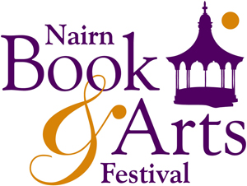
Submission form: Nairn Open Exhibition

Please read the Nairn Open Exhibition Guidelines before completing this form.

Your details: (Your data will be kept confidential by the Festival and will not be supplied to any third parties.)

First name | Surname | Address | Postcode | Tel number | Mobile | Email

If you wish to be added to the Festival E-newsletter list to be kept up to date with exhibition and event news, please put ‘X’ here ____________

Continues../

Work details: (max of two entries. Each entry should be no more than 4 years old on 1 June 2026)
Title of Work | Price/ NFS (NB please note if you are VAT registered the price should include VAT) | Medium and date (year) *NB no giclee prints | Size (max 100cm on longest side including frame)

Digital images must be jpeg format, 300dpi, a minimum of 1MB, and no larger than 2.5MB in size.
Please submit form and images to: nairnfestivalassistant@gmail.com by 31 July 2026
________________________________________________________________________________________________________
Festival use
 | Accepted Y/N | Sold Y/N | Commission and balance to artist if sold | Notes
Work 1

Work 2

